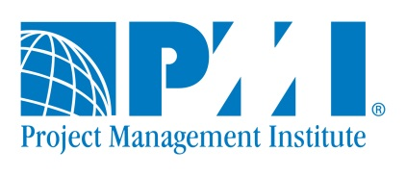
PMI Research and Education Conference 2014

Help us get the word out about PMI’s research program. How did you hear about this call for submissions?

(Please circle all options that apply)
- PMI
  - PMI e-mail
  - PMI homepage
  - Project Management Journal® (PMJ)
  - PM Network®
  - PMI event
  - PMI online community of practice
  - PMI chapter
  - PMI CoP
  - PMI staff
  - Aware of/applied for PMI research grant
  - Aware of/submitted to prior PMI Research Conferences
  - Attended or presented at prior PMI Research Conferences
- Ad in The Chronicle of Higher Education
- List-serv post (AOM, IRNOP, EURAM, etc). Please indicate: ________________________
- From a colleague
- Other (please specify) _____________________________________________________

